**AS23CSE111**

**OBJECT ORIENTED PROGRAMMING**

**LAB REPORT**



**Department of Computer Science Engineering**

**Amrita School of Computing**

**Amrita Vishwa Vidyapeetham, Amaravati Campus**

**Name:** K. Sai Mahalakshmi

**Roll No:** AV.SC.U4CSE24248

**Verified By:**

**INDEX**

|  |  |  |  |
| --- | --- | --- | --- |
|  |  |  |  |
|  |  |  |  |
|  |  |  |  |
|  |  |  |  |
|  |  |  |  |

**WEEK -1**

**Program -1:**

**Aim:**

Download and Install Java Software

**Procedure:**

**Step-1: Download JDK-21**

* Go to web browser and type Oracle JDK Download.
* Now click on the official website.
* Scroll down to the Java SE Development Kit 21.0.6 downloads section.
* Choose the operating system (macOS, Windows, Linux).
* Click on Download, then wait for the download to complete.

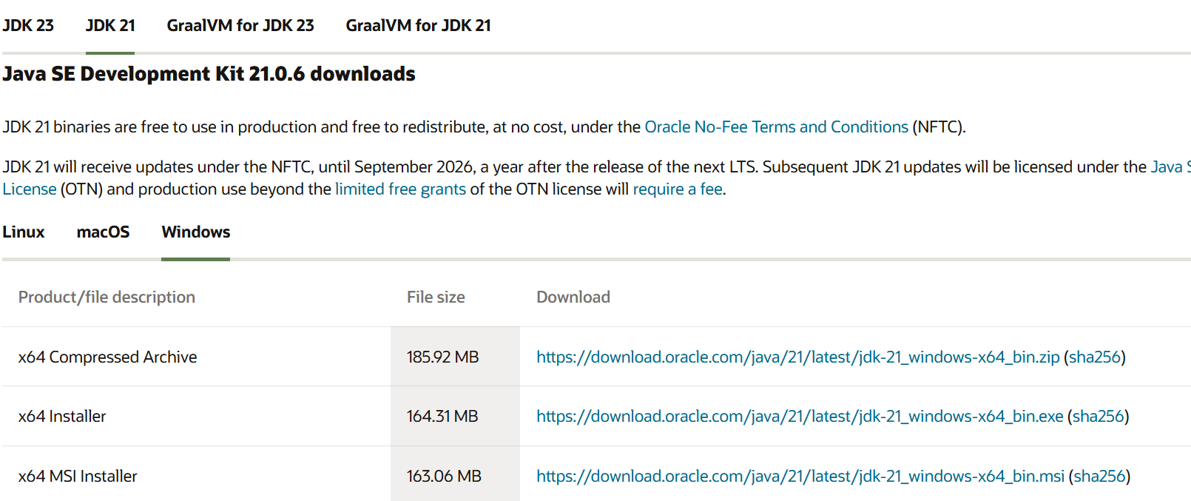

**Step 2:** **Install JDK 21**

* Locate the downloaded jdk-21_windows-x64_bin.exe file.
* Double-click to launch the installer.
* Click Next on the setup wizard.
* Choose the installation path (default is C:\Program Files\Java\jdk-21).
* Click Next, then click Install, wait for the installation to complete.
* Click Close once the installation is finished.

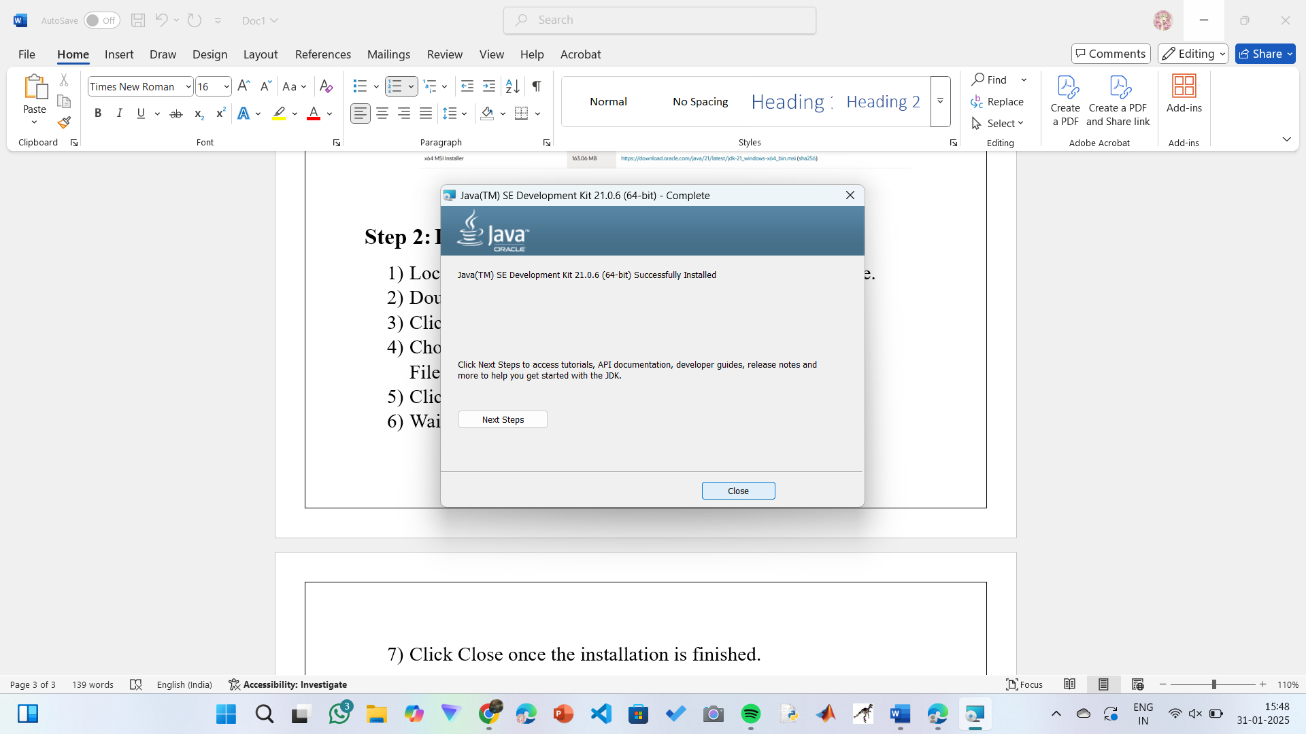

**Step 3: Setting up the path**

* Go to “Windows C” Drive on Desktop.
* Choose Program Files, select Java, then JDK 21, then select Bin.
* Select and copy the path at the address bar.

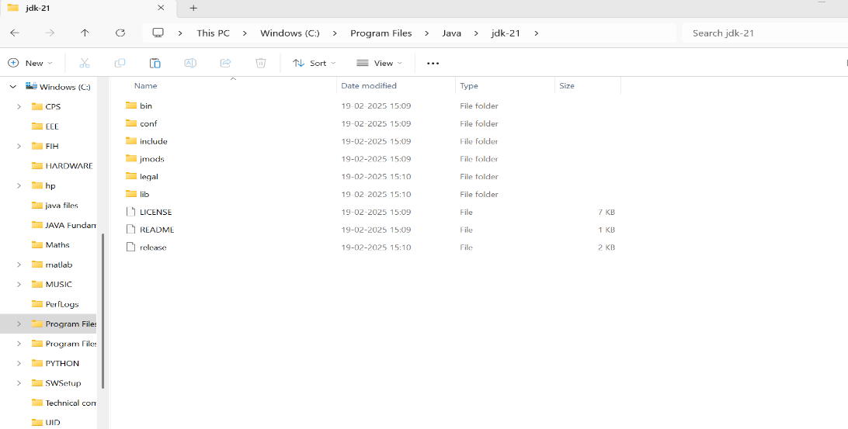

**Step 4: Open System Properties**

* Open file explorer, then right click on This PC.
* Next select on properties then it will take you to the settings app.
* Click on Advanced tab.
* Click on Environment Variables at the bottom.

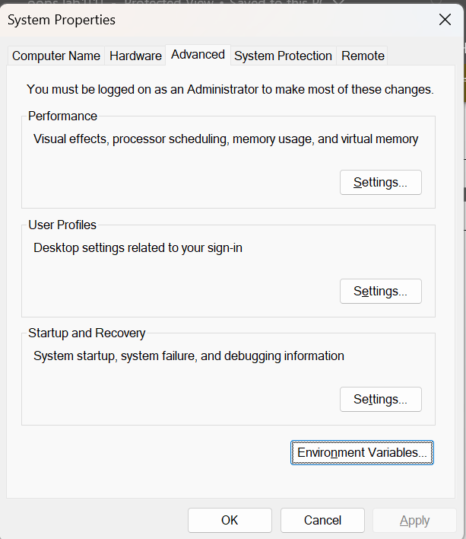

**Step 5: Set JAVA_HOME**

* Under System Variables, click New.
* Set the Variable name as JAVA_HOME.
* Set Variable value as C:\Program Files\Java\jdk-21 (or your installation path).
* Click OK.

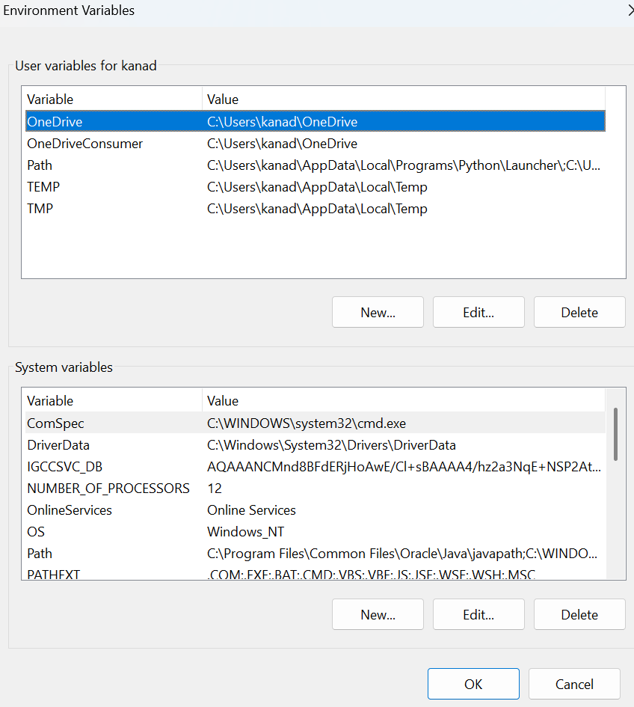

**Step 6: Update PATH Variable**

* In System Variables, find Path and click Edit.
* Click New and add: C:\Program Files\Java\jdk-21\bin.
* Click OK to save.

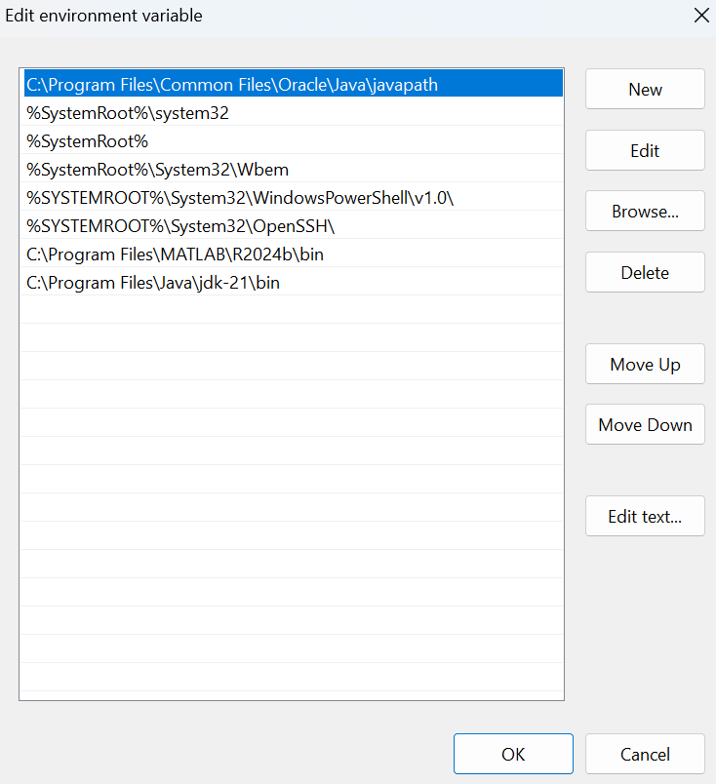

**Step 7:Verify Installation**

* Open Command Prompt.
* Type the following command: **java --version** and press Enter.

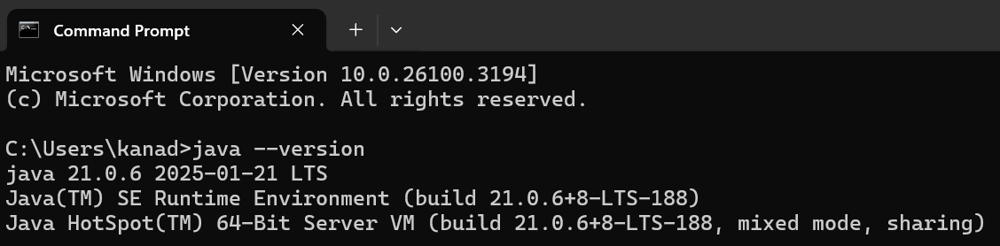

* To check the java compiler type: **javac --version.**

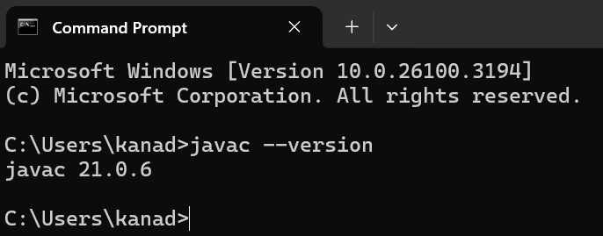

**Program-2:**

**Aim:**

Write a program that prints Helloworld.

**Code:**

class Helloworld {

public static void main(String[] args) {

System.out.print("Hello World");

}

}

**Output:**

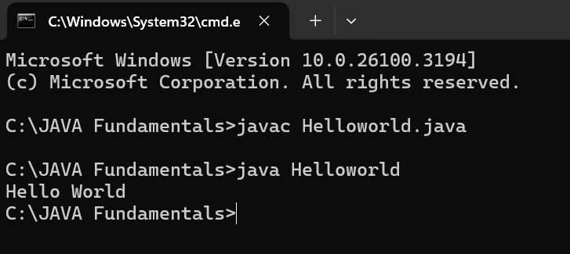

|  |  |
| --- | --- |
| Error Found | Error Rectified |
| None Found | None Rectified |

**Program-3:**

**Aim:**

Write a program that prints Student details.

**Code:**

class Studentdetails {

public static void main(String[] args) {

System.out.println("Name: K. Sai Mahalakshmi");

System.out.println("Branch & Section: CSE-C");

System.out.print("University: Amrita Vishwa Vidyapeetham");

}

}

**Output:**

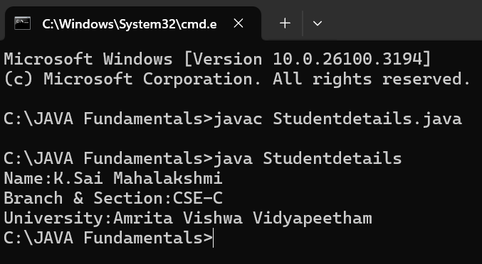

|  |  |
| --- | --- |
| Error Found | Error Rectified |
| The class name should start with capital letter. | I had changed the first letter from small to capital. |

**WEEK-2**

**Program-1:**

**Aim:**

Write a program to calculate area of rectangle.

**Code:**

import java.util.Scanner;

class Area {

public static void main(String[] args) {

Scanner input = new Scanner(System.in);

System.out.print("Enter length: ");

float length = input.nextFloat();

System.out.print("Enter width: ");

float breadth = input.nextFloat();

input.close();

float area = length * breadth;

System.out.println("Area of rectangle: " + area);

}

}

**Positive Output:** 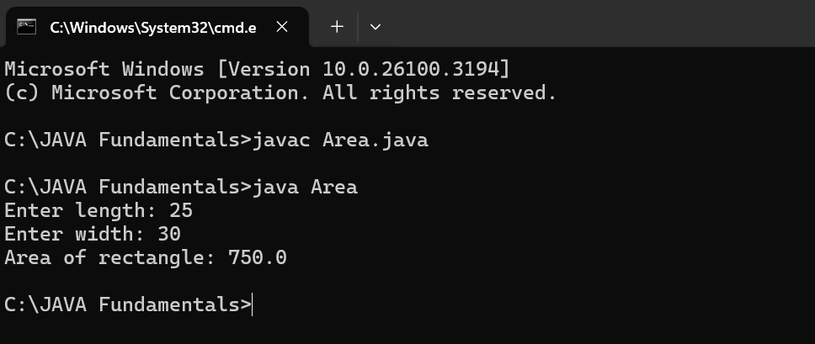

**Negative output:**

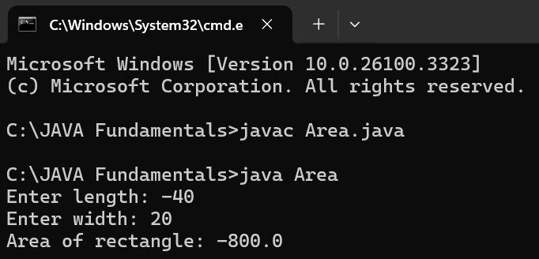

**IMPORTANT POINTS :**

The program uses java.util.Scanner to take input from the user for:

Length of the rectangle.

Breadth of the rectangle.

|  |  |
| --- | --- |
| Error Found | Error Rectified |
| Error: ‘;’ expected | Need to put ‘;’ at the end |

**Program-2:**

**Aim:**

Write a program to convert temperature from fahrenheit to Celsius and vice versa.

**Code:**

import java.util.Scanner;

class Temperature {

public static void main(String[] args) {

Scanner input = new Scanner(System.in);

System.out.print("Enter Temperature in Fahrenheit: ");

float F = input.nextFloat();

input.close();

float C = (F - 32)*5/9;

System.out.println("Temperature in celsius: " + C);

}

}

**Positive Output:**

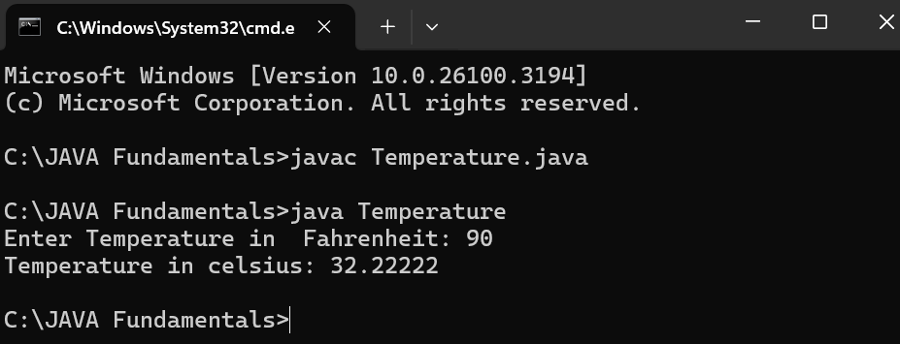

**Negative Output:**

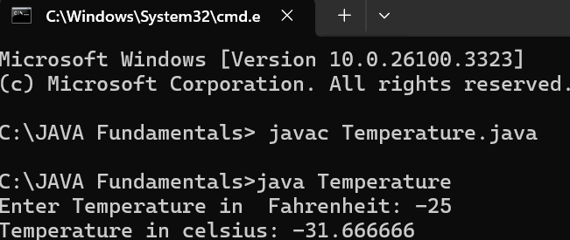

**Code:**

import java.util.Scanner;

class Temperature2 {

public static void main(String[] args) {

Scanner input = new Scanner(System.in);

System.out.print("Enter Temperature in Celsius: ");

float C = input.nextFloat();

input.close();

float F = (C * 9/5) + 32;

System.out.println("Temperature in Fahrenheit: " + F);

}

}

**Positive Output:**

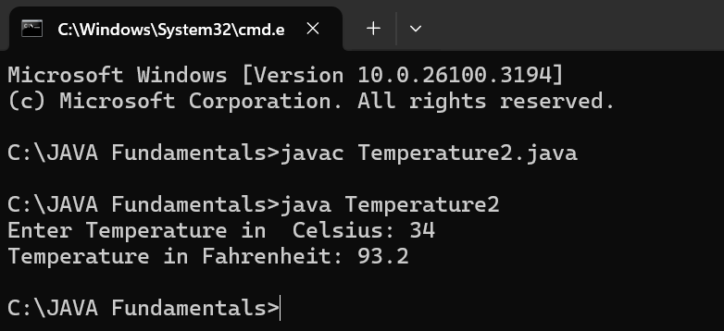

**Negative Output:**

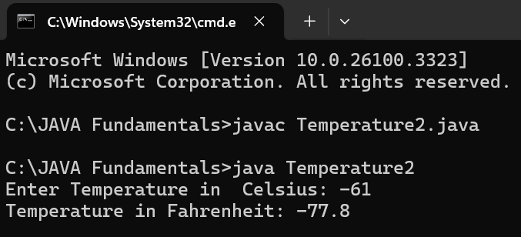

**IMPORTANT POINTS:**

The line “Scanner input = new Scanner(System.in),” tends to create a new Scanner object named “input” that reads input from the standard input stream (System.in), like keyboard.

|  |  |
| --- | --- |
| Error Found | Error Rectified |
| While printing the variable not giving + sign. | We should give correct indentation. |

**Program-3:**

**Aim:**

Write a program to calculate simple interest.

**Code:**

import java.util.Scanner;

class Simple_interest {

public static void main(String[] args) {

Scanner input = new Scanner(System.in);

System.out.print("Enter principle: ");

float p = input.nextFloat();

System.out.print("Enter time: ");

float t = input.nextFloat();

System.out.print("Enter rate: ");

float r = input.nextFloat();

input.close();

float SI = (p*t*r)/100;

System.out.println("Simple Interest : " +SI );

}

}

**Positive Output:**

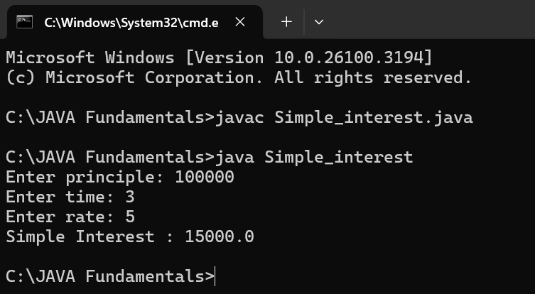

**Negative Output:**

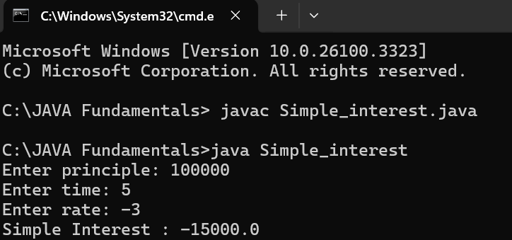

**IMPORTANT POINTS:**

line “import java.util.Scanner” indicates:

Import: tells the java compiler that we want to use a specific class in code.

Java.util : It contains utility classes for Java programming.

Scanner: It is the class that allows you to read input from the keyboard.

|  |  |
| --- | --- |
| Error Found | Error Rectified |
| The class name should start with capital letter | I had changed the first letter from small to capital. |

**Program-4:**

**Aim:**

Write a program to calculate Area of triangle.

**Code:**

public class Areaoftriangle {

public static void main(String[] args) {

double s1, s2, s3;

double area, resArea;

s1 = 25.0;

s2 = 30.0;

s3 = 5.0;

area = (s1+s2+s3)/2.0d;

resArea = Math.sqrt(area* (area - s1) * (area - s2) * (area - s3));

System.out.println("Area of Triangle = " + resArea);

}

}

**Output:**

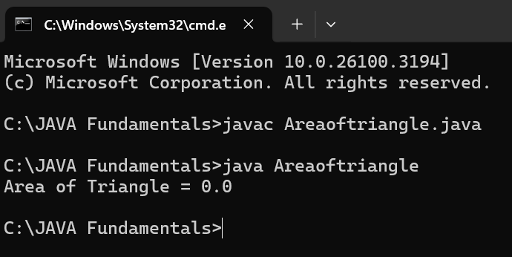

|  |  |
| --- | --- |
| Error Found | Error Rectified |
| Error: Double s1, s2, s3;  ^ | Rectified: double s1,s2,s3; |

**Program-5:**

**Aim:**

Write a program to calculate Factorial of a number.

**Code:**

import java.util.Scanner;

public class Factorial {

public static void main(String[] args) {

Scanner input = new Scanner(System.in);

System.out.print("Enter number: ");

int n = input.nextInt();

input.close();

long factorial = 1;

for (int i = 1; i <= n; i++) {

factorial*= i;

}

System.out.println("Factorial of " + n + " is: " + factorial);

}

}

**Positive Output:**

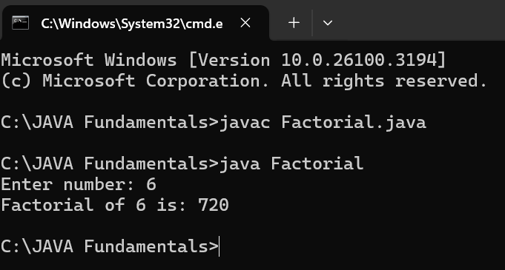

**Negative Output:**

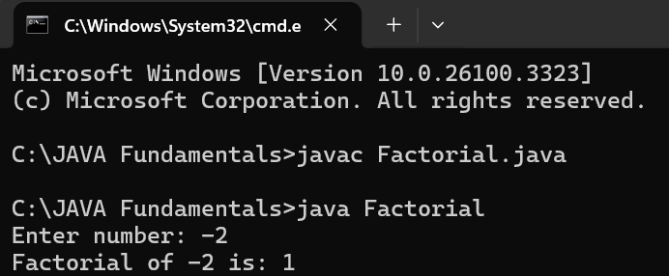

**IMPORTANT POINTS:**

The factorial of n is calculated using a for loop.

we are using the data type “int” just to calculate the integer values and it doesn’t support floating points.

|  |  |
| --- | --- |
| Error Found | Error Rectified |
| System.out.print(Enter number: ): “ ” ,’;’expected; | System.out.print(“Enter number:” ); |

**Program-6:**

**Aim:**

Write a program to calculate Fibonacci series.

**Code:**

import java.util.Scanner;

public class Fibonacci {

public static void main(String[] args) {

Scanner scanner = new Scanner(System.in);

System.out.print("Enter the number of terms: ");

int terms = scanner.nextInt();

long firstTerm = 0, secondTerm = 1;

System.out.println("Fibonacci Series up to " + terms + " terms:");

for (int i = 1; i <= terms; ++i) {

System.out.print(firstTerm + " ");

long nextTerm = firstTerm + secondTerm;

firstTerm = secondTerm;

secondTerm = nextTerm;

}

}

}

**Positive Output:**

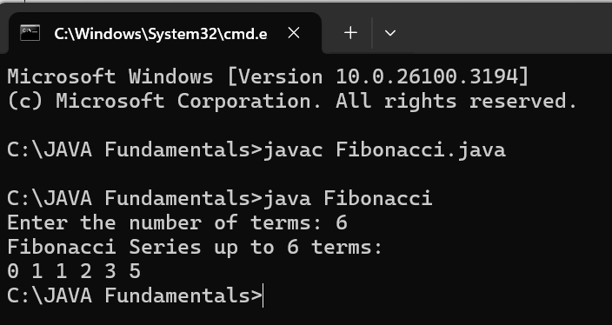

**Negative Output:**

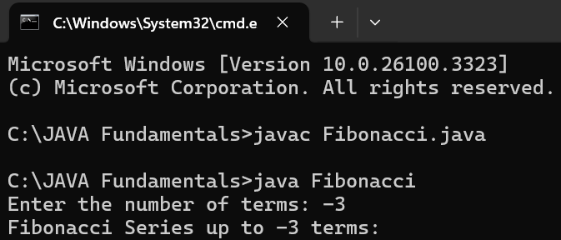

**IMPORTANT POINTS:**

We use while loop in this program.

The process in this program is repeated certain number of times until the conditions meet.

|  |  |
| --- | --- |
| Error Found | Error Rectified |
| Fibonacci.java:12: error: ';' expected | At the end firstTerm = secondTerm should have; |

**WEEK-3**

**1. AIM:**

**To create java program with following instructions:**

Create a class with a name car.

Create four attributes named car_color, car_brand, fuel_type, mileage.

Create three methods named start(), stop(), service().

Create the objects named car1, car2, car3.

**Code:**

public class Car {

private String car_color;

private String car_brand;

private String fuel_type;

private String mileage;

public void start() {

System.out.println("car is started");

}

public void stop() {

System.out.println("car is stopped");

}

public void service() {

System.out.println("car is for service");

}

public static void main(String args[]) {

Car car1 = new Car();

car1.car_color="black";

car1.car_brand="BMW";

car1.fuel_type="diesel";

car1.mileage="20";

car1.start();

car1.stop();

car1.service();

System.out.println("car_color:"+car1.car_color);

System.out.println("car_brand:"+car1.car_brand);

System.out.println("fuel_type:"+car1.fuel_type);

System.out.println("mileage:"+car1.mileage);

Car car2 = new Car();

car2.car_color="white";

car2.car_brand="audi";

car2.fuel_type="petrol";

car2.mileage="20";

car2.start();

car2.stop();

car2.service();

System.out.println("car_color:"+car2.car_color);

System.out.println("car_brand:"+car2.car_brand);

System.out.println("fuel_type:"+car2.fuel_type);

System.out.println("mileage:"+car2.mileage);

Car car3 = new Car();

car3.car_color="white";

car3.car_brand="Benz";

car3.fuel_type="petrol";

car3.mileage="10";

car3.start();

car3.stop();

car3.service();

System.out.println("car_color:"+car3.car_color);

System.out.println("car_brand:"+car3.car_brand);

System.out.println("fuel_type:"+car3.fuel_type);

System.out.println("mileage:"+car3.mileage);

}

}

**Output:**

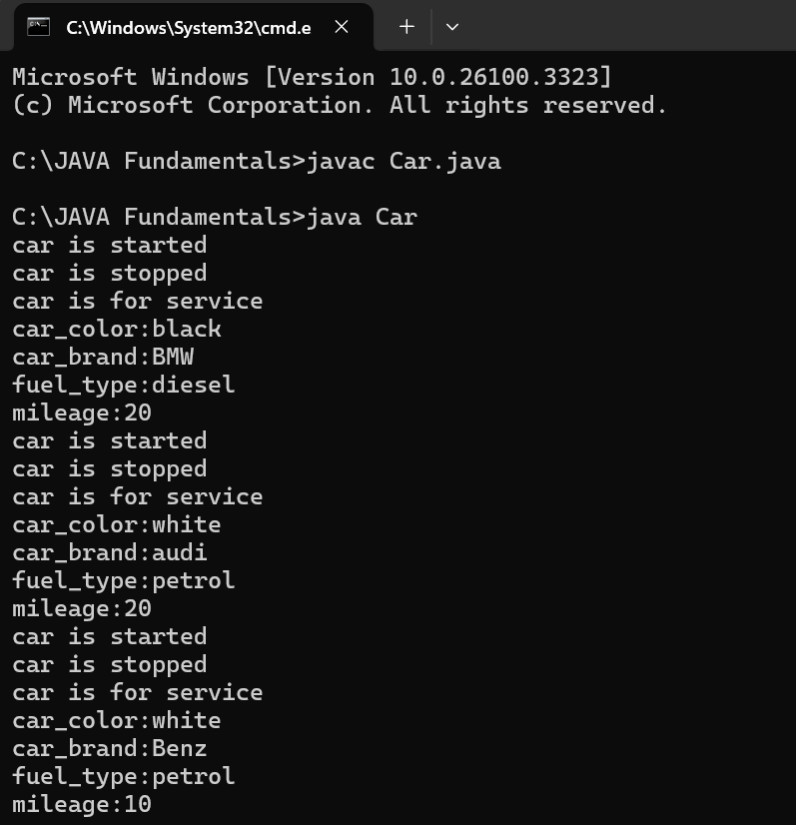

**IMPORTANT POINTS:**

The program defines a car class that represents a car's attributes and behaviors.

The class contains four attributes.

Three methods define car behaviors.

Three car objects (car1,car2,car3) are created with different attributes.

|  |  |
| --- | --- |
| Error Found | Error Rectified |
| Error: system.out.println  ^ in system ‘s’should be capital |  |